Creating a Journal Entry

A journal is a self-reflective tool that allows you to post personal reflections about the course or discuss and analyze course related materials. Each journal entry can include any combination of text, images, links, multimedia, and attachments.

Although it is possible to set journals to public, allowing other students to view your journal, instructors typically do not enable this, so only you and your instructor are able to read and add comments to your entries. If you are not sure, before posting, ask your instructor if the journal is set to public or private.

The journal icon resembles a spiral notebook. Click the title of the journal to create your entry.

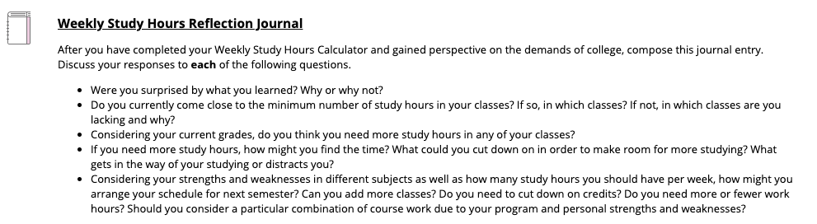

After clicking on the journal title, you will arrive at the journal overview. This page contains the journal instructions. If you have posted to the journal previously, you will find those posts listed below.

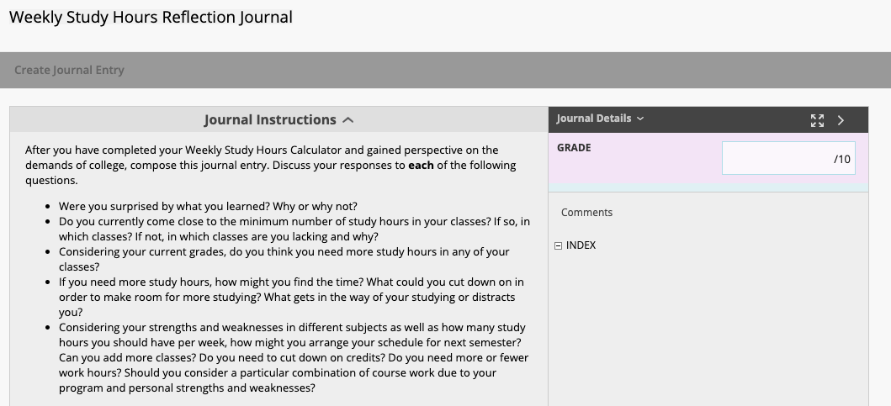

You can see your total number of entries and comments by clicking the down arrow next to Journal Details on the right.
To add your own entry to the journal, click the button.
Enter a title and then click into the Entry Message text box and type your journal entry. Clicking the three dots button in the text editor will expand it, giving you more options.

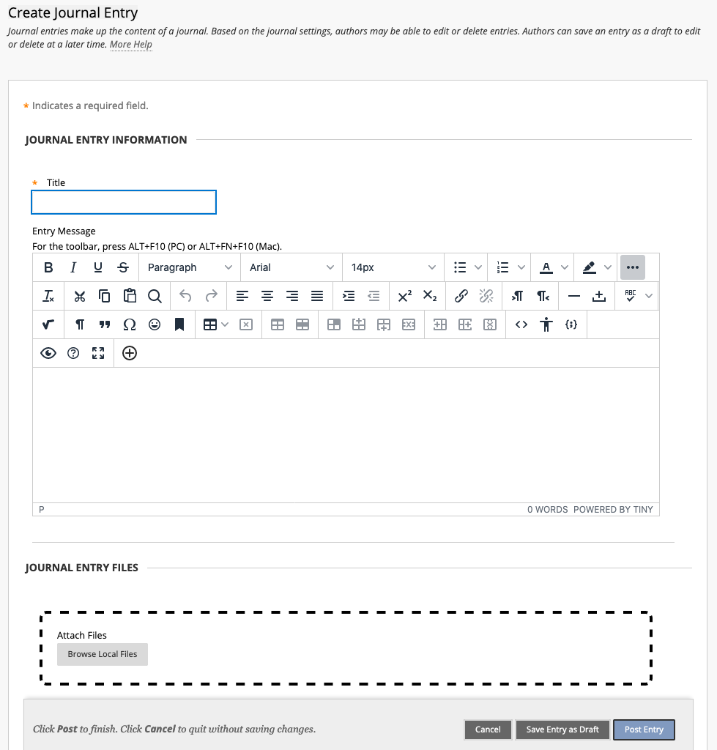

Click when you have completed your journal.

You and your instructor can enter comments on journal posts if enabled. To add a comment, click the button at the bottom of your entry.

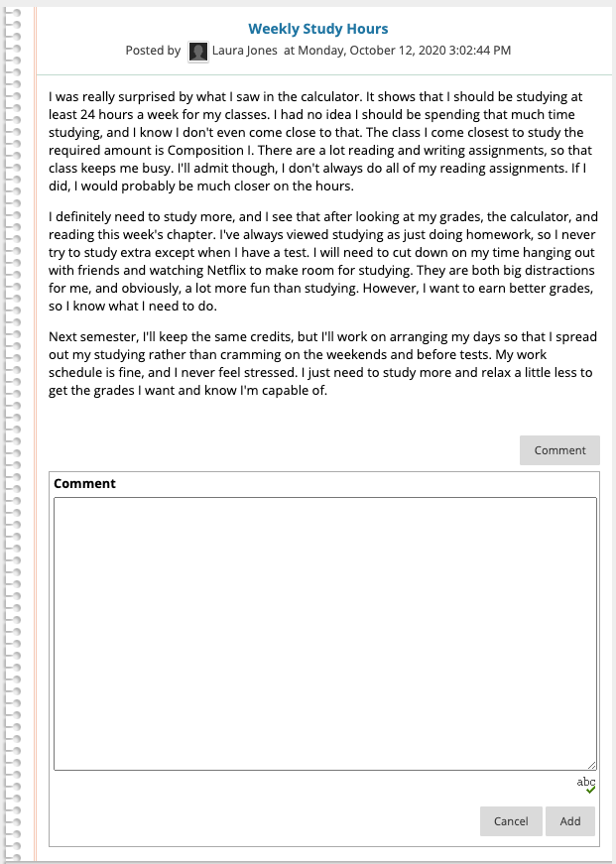

Enter a comment in the Comment field and click Add. You can view comments by clicking Comments beneath an entry.

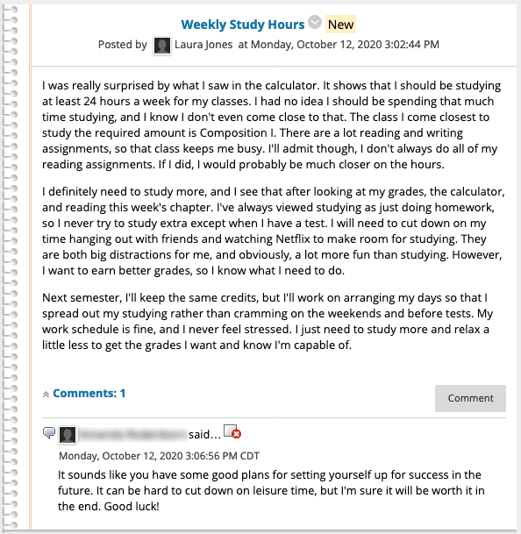

Journals created in Blackboard can only be viewed from Blackboard; they are not publicly accessible. Journals do not support RSS, so you cannot subscribe for updates to the journal. The only way to check for comments is to navigate to the journal in Blackboard.

